**SQL ASSIGNMENT 1**

1. **Desgin the above database with following table by applying Primary key and Foreign key.**

/* Creating Database */

CREATE DATABASE Assignment

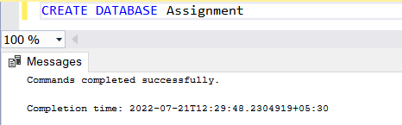

/*Creating Tables with Primary and Foreign Keys*/

CREATE TABLE Customer (

id int NOT NULL PRIMARY KEY ,

FirstName nvarchar(40),

LastName nvarchar(40),

City nvarchar(40),

Country nvarchar(50),

Phone nvarchar(20),

)

CREATE TABLE Orders (

id int NOT NULL PRIMARY KEY ,

OrderDate datetime,

OrderNumber nvarchar(10),

CustomerId int FOREIGN KEY REFERENCES Customer(id) ON DELETE CASCADE,

TotalAmount decimal(12,2),

)

CREATE TABLE Product(

id int NOT NULL PRIMARY KEY,

ProductName nvarchar(50),

UnitPrice decimal (12,2),

Package nvarchar(30),

isDiscontinued bit

)

CREATE TABLE OrderItem (

id int NOT NULL PRIMARY KEY,

OrderId int FOREIGN KEY REFERENCES Orders(id) ON DELETE CASCADE,

ProductId int FOREIGN KEY REFERENCES Product(id) ON DELETE CASCADE,

UnitPrice decimal (12,2),

Quantity int

)

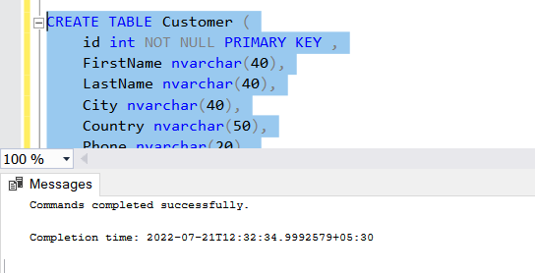

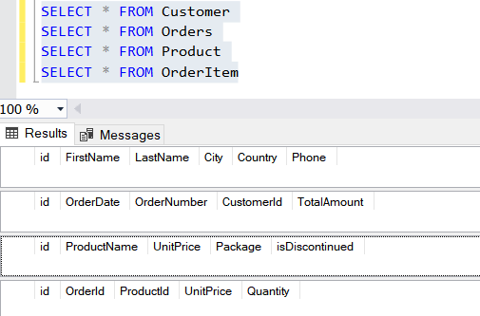

1. **Insert Records in all tables.**

INSERT INTO Customer VALUES (1, 'Arfin', 'Sayyed', 'Mumbai', 'India',1231231231)

INSERT INTO Customer VALUES (2, 'Maziya', 'Shaikh', 'Melbourne', 'Australia',4564564564)

INSERT INTO Customer VALUES (3, 'Tasneem', 'Goawala', 'Sydney', 'Australia',7897897897)

INSERT INTO Customer VALUES (4, 'Aariz', 'Sayyed', 'Berlin', 'Germany',3213213213)

SELECT * FROM Customer

INSERT INTO Orders VALUES (1,'2022-07-07 07:06:45',001 , 1,5000)

INSERT INTO Orders VALUES (2,'2022-07-08 08:30:02',002 , 2,300)

INSERT INTO Orders VALUES (3,'2022-07-08 10:07:00',003 , 2,200)

INSERT INTO Orders VALUES (4,'2022-07-09 11:06:45',004 , 3,5500)

SELECT * FROM Orders

INSERT INTO Product VALUES (1,'Wine', 400,'Box', 0)

INSERT INTO Product VALUES (2,'Sparkling Water', 40,'Plastic', 0)

INSERT INTO Product VALUES (3,'Mineral Water', 20,'Plastic', 1)

INSERT INTO Product VALUES (4,'Chocolate',10,'Box', 1)

SELECT * FROM Product

INSERT INTO OrderItem VALUES (1,1,1,400,1)

INSERT INTO OrderItem VALUES (2,2,2,40,2)

INSERT INTO OrderItem VALUES (3,3,3,20,2)

INSERT INTO OrderItem VALUES (4,4,4,10,1)

SELECT * FROM OrderItem

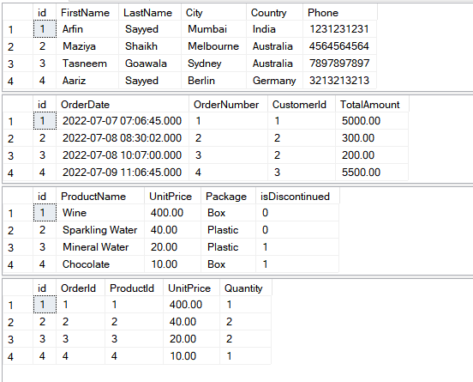

1. **In Customer table FirstName Attribute should not accept null value.**

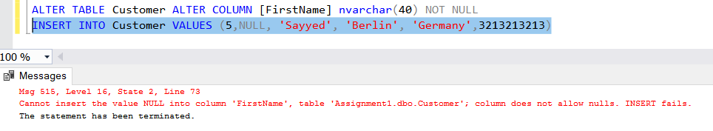

1. **In Order table OrderDate should not accept null value.**

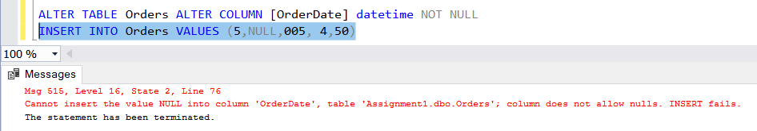

1. **Display all customer details**

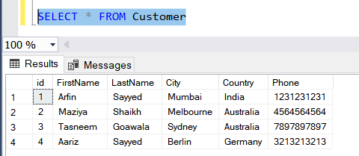

1. **Write a query to display Country whose name starts with A or I.**

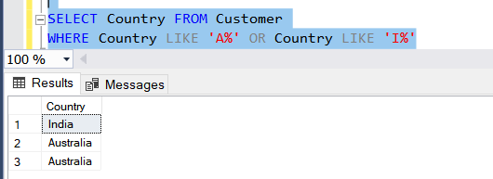

1. **Write a query to display whose name of customer whose third character is I**

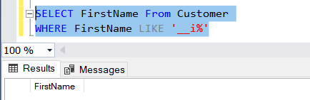

**SQL ASSIGNMENT 2**

1. **Display the details from Customer Table who is from country Germany.**

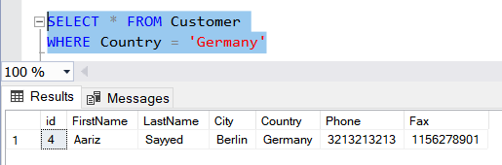

1. **Display the fullname of employee.**

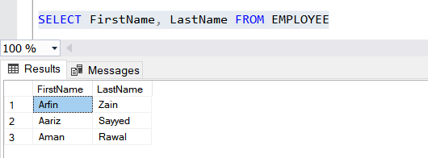

1. **Display all customer who have fax number.**

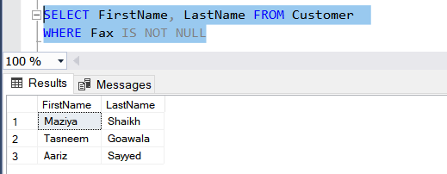

1. **Display the customer details whose name holds second letter as U.**

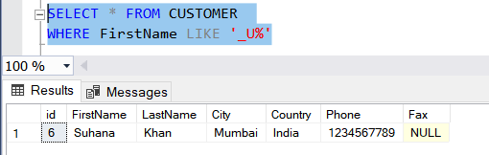

1. **Select order details where unit price is greater than 10 and less than 20.**

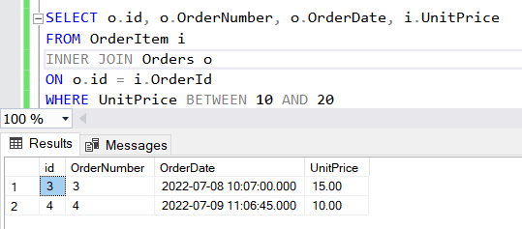

1. **Display order details which contains shipping date and arrange the order by date.**

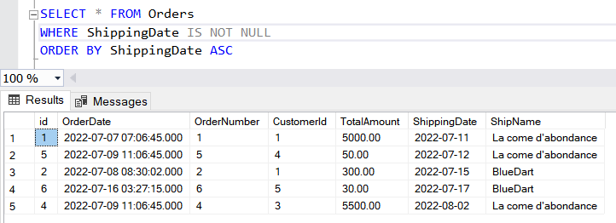

1. **Print the orders shipped by shipname 'La come d'abondance' between 2 dates.**

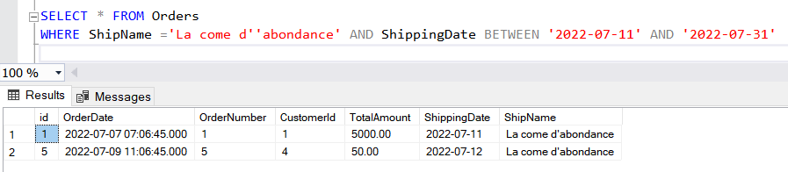

1. **Print the products supplied by Exotic Liquids.**

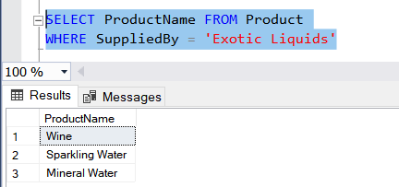

1. **Print the average quantity ordered for every product.**

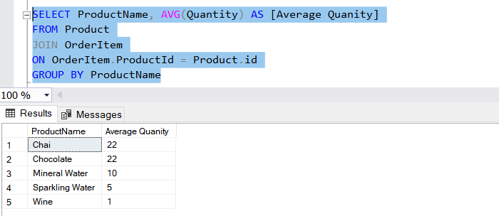

1. **Print all the shopping company name and the ship names if they are operational.**

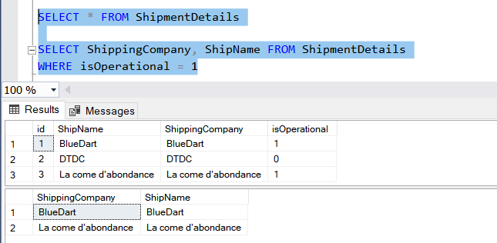

1. **Print all employees with Manager Name.**

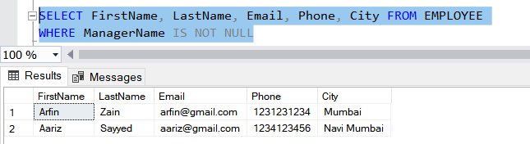

1. **Print the bill for a given order id.bill should contain Productname, Categoryname, price after discount.**

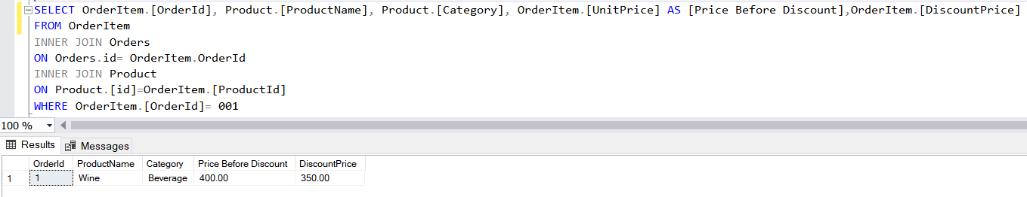

1. **Print the total price of orders which have the products supplied by 'Exotic Liquids' if the price is > 50 and also print it by shipping company's name.**

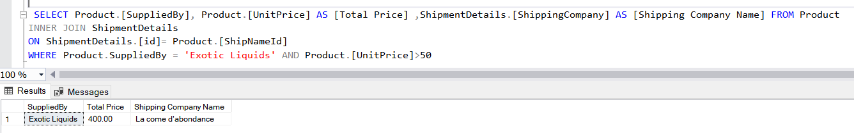

**SQL ASSIGNMENT 3**

1. **Write a query to display the orders placed by customer with phone number 030-0074321**

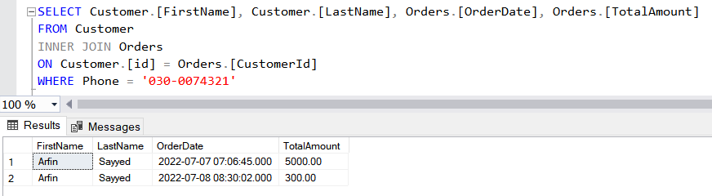

1. **Fetching all the products which are available under Category ‘Seafood’.**

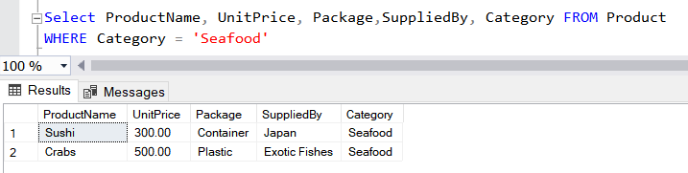

1. **Display the orders placed by customers not in London.**

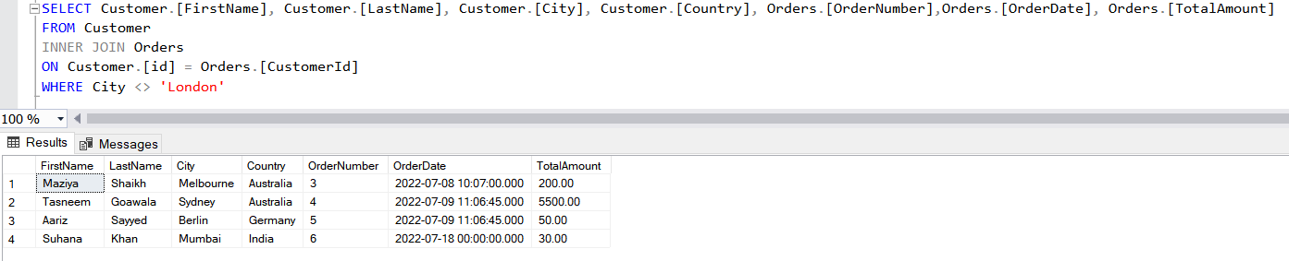

1. **Select all the order which are placed for the product Chai.**

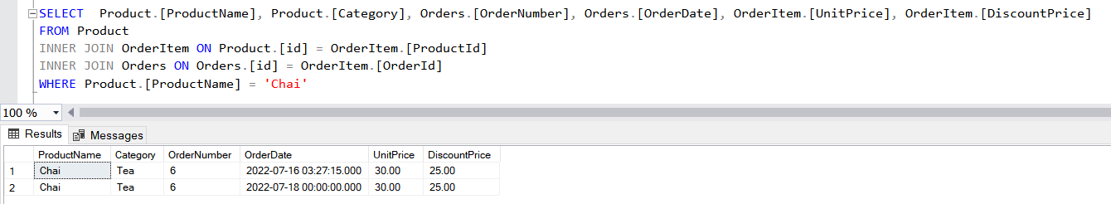

1. **Write a query to display the name , department name and rating of any given employee.**

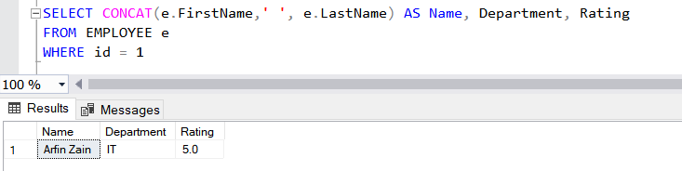

**SQL ASSIGNMENT 4**

1. **Print the Total price of orders which have the products supplied by 'Exotic Liquids' if the price is > 50 and also print it by Shipping company's Name.**

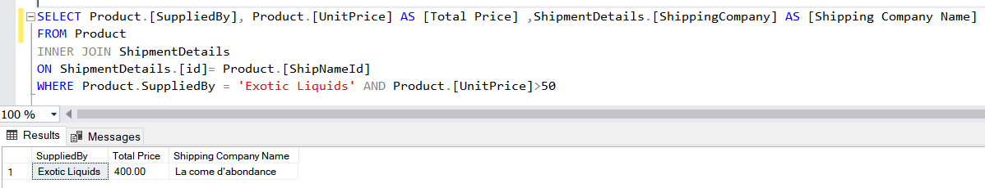

1. **Display the employee details whose joined at first.**

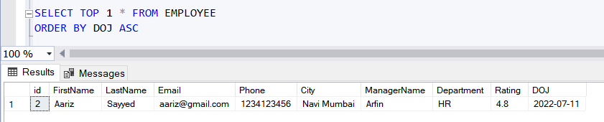

1. **Display the employee details whose joined at recently.**

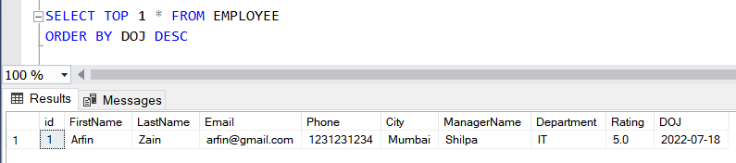

1. **Write a query to get most expense and least expensive Product list (name and unit price).**

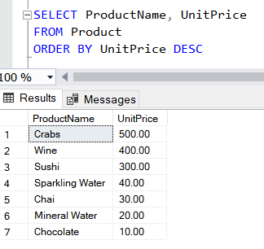

1. **Display the list of products that are out of stock.**

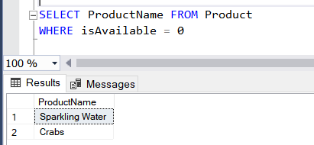

1. **Display the list of products whose unitinstock is less than unitonorder.**

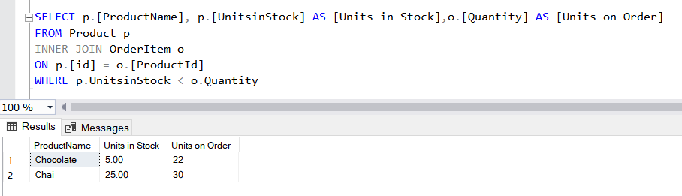

1. **Display list of categories and suppliers who supply products within those categories.**

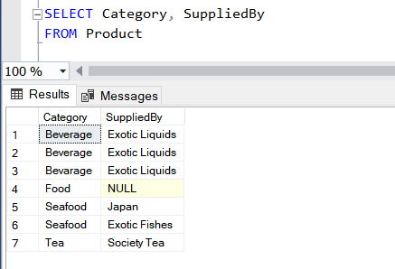

1. **Display complete list of customers, the OrderID and date of any orders they have made.**

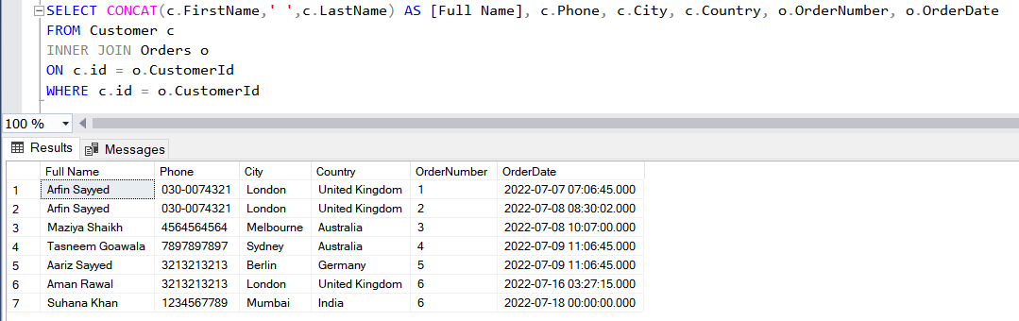

1. **Write query that determines the customer who has placed the maximum number of orders.**

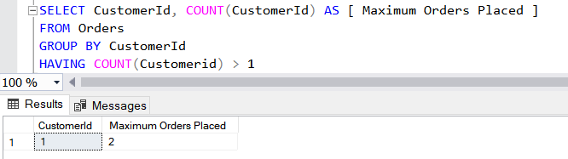

1. **Display the customerid whose name has substring ‘RA’.**

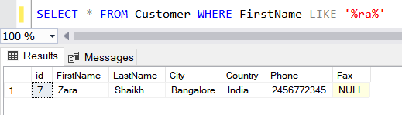

1. **Display the first word of all the company name.**

